**Group D5 – Student Residence**

**Daniel Tilley – C14337041**

We originally submitted an ERD (as seen below), but were unhappy with how it looked when we were given feedback. We then decided to use the solution ERD for our assignment as we felt it would be easier to implement knowing it was as good as it could be.

We noticed that the solution ERD (as seen below) was missing two columns in one of the tables. In the Inspection table, it appeared as though there was no column for a rating of the room or for any comments about the room. The problem was quickly solved by adding in two new columns. One was called “Comments” and the other “Rating”.

When we then went to implement the ERD, we once again noticed a problem. Some of the columns in the ERD used keywords or function names. In our respected tables (labelled bellow in the first draft ERD) we went about making sure no keywords were used in any column names. In my tables (Order, OrderItem and MenuItem) there were a total of three changes. The column “Name” was changed to “ItemName” in both the OrderItem and MenuItem tables and the column “Cost” was changed to “ItemCost”.

Attached is all my PL/SQL files. These include five function files, one procedure file and one PL/SQL anonymous block. These files are used in tandem to add a bar order to the database and display the total of that order along with the order contents back to the user.

**Original Submission**

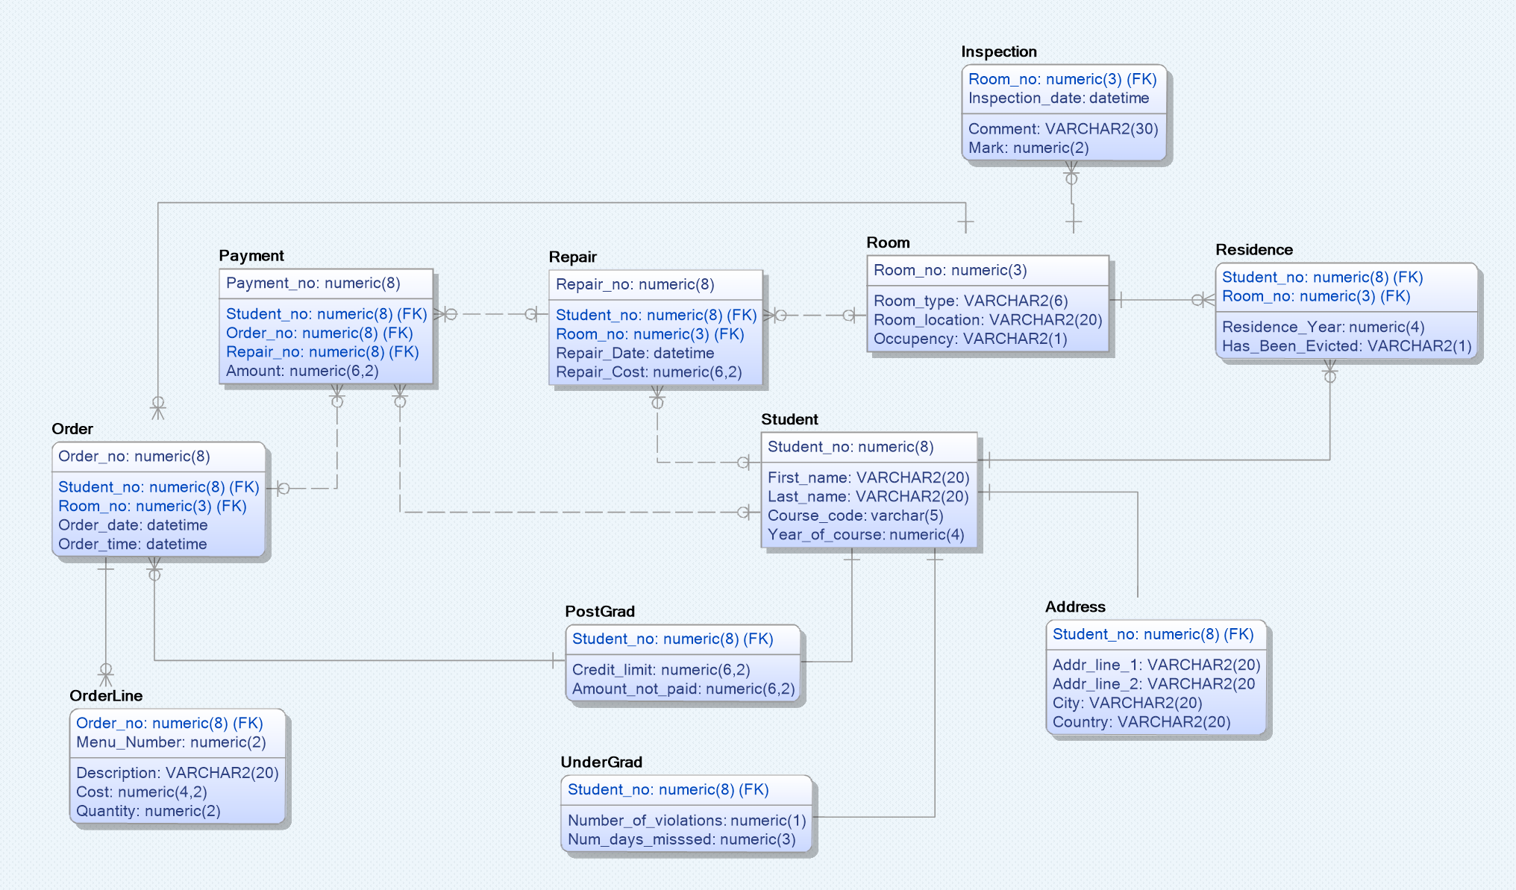

**Solution ERD**

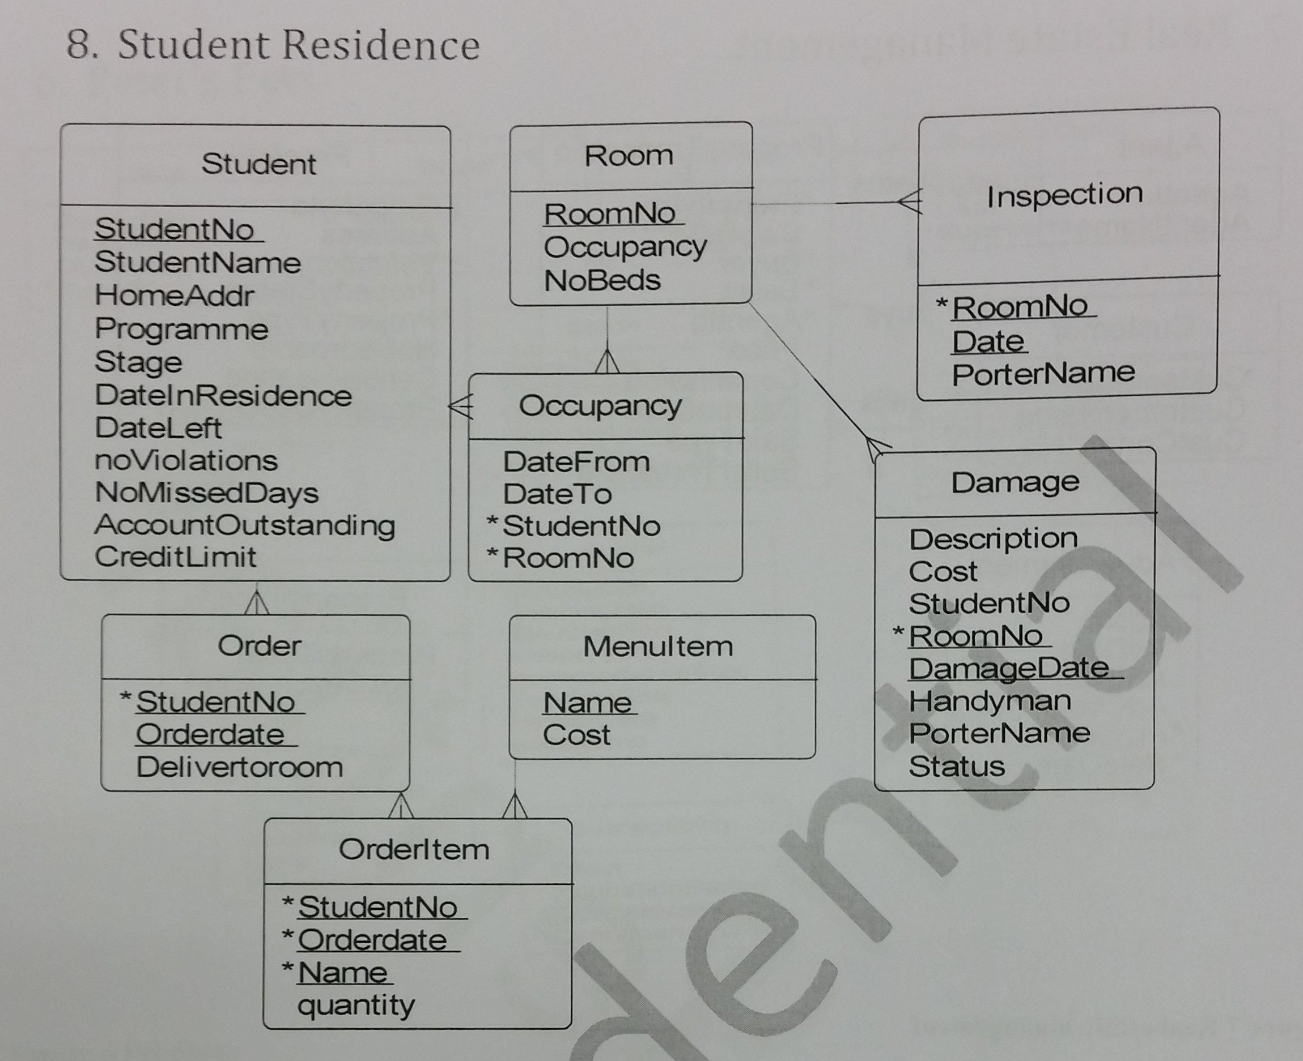

**First Draft (making changes)**

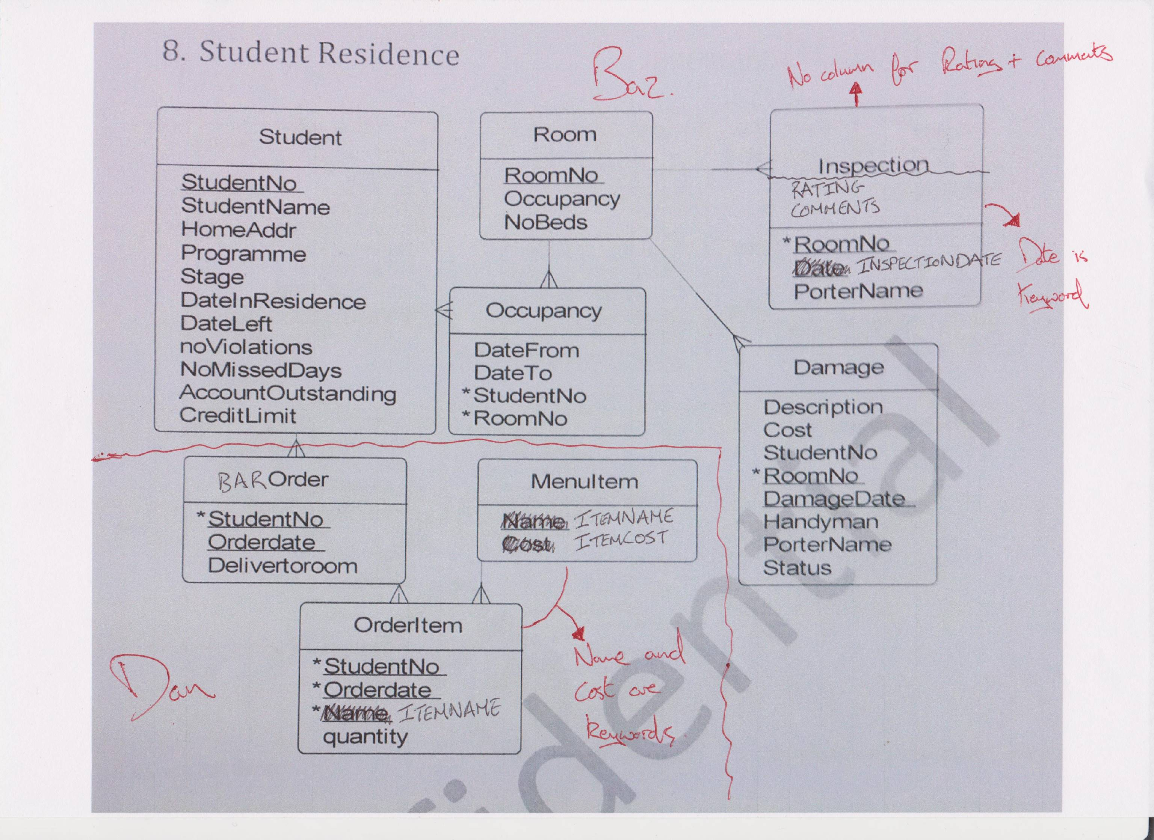

**Final Draft (Our Current ERD)**

